Enforcement Key Gap in Local AIS Programs
By Jeff Forester
Many of you write to MLR with a simple question about aquatic invasive species (AIS) programs in Minnesota; "Why can't Minnesota use mandatory roadside inspections. Trying to cover all accesses is so difficult and expensive.” Others ask if it is possible to, “Tag inspected boats so that they can launch safely without having to be re-inspected,” or “Can we set up a system so that boaters who launch into and out of one lake can get a special pass since they pose no threat of transporting AIS.
Many of us have traveled to western states where these types of programs are well established.
These are good questions. A tagging system combined with a centralized inspection/decontamination program would make Minnesota's efforts to stop the spread of Aquatic Invasive Species both more effective and far more efficient. We have laws on the books that would allow us to start using these tools.
So why have we not done these things?
In early March a number of Minnesota legislators, legislative staff and members of the Statewide AIS Advisory Committee learned the answer. Lack of effective partnership and collaboration. Let me explain.
On Thursday, Feb. 24th, at 3:00 legislators were invited to an AIS learning session held by Senator Bill Ingebrigtsen, Senator Carrie Rudd, and Rep. Dan Fabian, Chairs of the Environment committees in the Minnesota House and Senate. The event was organized and sponsored by Gabriel Jabbour of Tonka Bay Marina, Minnesota Lakes and Rivers Advocates, and the MN DNR Statewide AIS Advisory Committee.
The speaker was Stephanie Showalter Otts, Executive Director of Sea Grant Law Center. Stephanie has spent the last six years working with the assistant attorney generals of western states to craft a legal framework that is effective, comprehensive and consistent. Western states have been able to accomplish many of the things Minnesota has not, and the reason seems to be the process used to draft the legislation used to create inspection and decontamination programs.
Ms. Showalter Otts convened a series of conferences for the Western Regional Panel that built program consensus by inviting AIS specialists, assistant attorneys general, and state law enforcement officials to help draft the enabling language for AIS laws in the Western Region, which is everything past the 100th Meridian. This language was then packaged as a legislative framework that the various western states could change or adopt.
In Minnesota MN DNR attorneys drafted our AIS laws. They were based in part upon the Western Regional Panel’s, but unlike in the west, none of those who would have to enforce the laws were consulted in advance, not county attorneys, AIS specialists, local law enforcement or the public. The MN DNR did not first build program consensus by including county attorneys and county sheriffs in the process as they were drafting language.

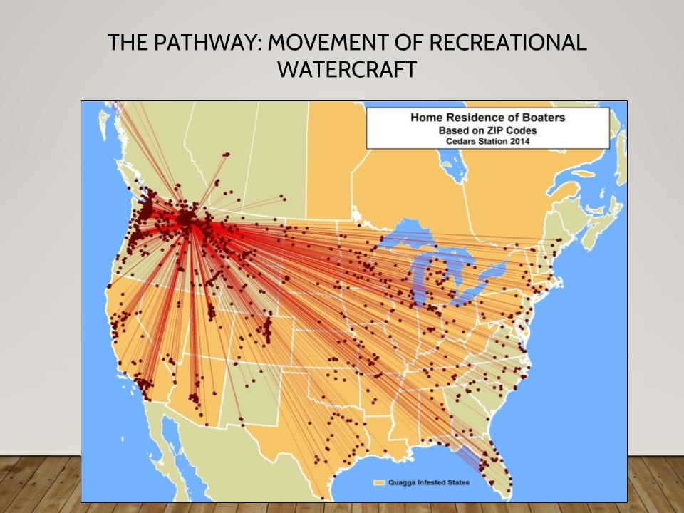
Idaho tracked the origin of every infested watercraft that has been intercepted at their Cedars Station inspection station. Idaho remains zebra mussel free.

As Ms. Showalter Otts said during the presentation, "Attorneys are concerned with worst case scenarios, and so we say 'no' a lot. We are trained to say 'no.'" For this reason some county attorneys have been cautious to allow local law enforcement to set up centralized inspection stations at “choke points” on Minnesota’s roads, to offer paperwork or a tag certifying inspection or decontamination.
If a driver parks a car illegally, they can expect that it might be towed away. Any resulting damage is on the owner, not the towing company. But with AIS prevention, concerns are raised that if a boater is directed from a public access to a specific decontamination station, and is involved in an accident on the way, the local government could be held responsible for damages.
The take-away is clear - partnering is important in all public policy discussions, and the earlier the partnership forms, the better. It is not just water related stakeholders that must be brought into AIS work, but enforcement agents, including the attorneys who will prosecute AIS laws and support law enforcement officers. There is a role for local AIS advocates to reach out to county attorneys, and educate them on the threats of AIS, the potential economic impacts that can follow an infestation (Mille Lacs) and the need to put together workable solutions to protect local economies and way of life.
It is time to bring together law enforcement, including county attorneys, to review the current statutes, agree on a workable framework, and then work to get these changes into law. MLR would like to thank Gabriel Jabbour, the MN DNR and Stephanie Showalter Otts for all the work they did to put this presentation together. Special thanks to Senator Bill Ingebrigtsen, Senator Carrie Rudd, and Representative Dan Fabian for sponsoring the event.
Jeff Forester is executive director of the Minnesota Lakes and Rivers Advocates.
MN Lakes & Rivers Advocates ~ PO Box 22262 ~ St. Paul, MN 55122
www.mnlakesandrivers.org ~ 952-854-1317 ~ judy@mnlakesandrivers.org

