Lake Home and Cabin Owners Protect Minnesota’s Water Heritage

By Jeff Forester

This year’s MLR Annual meeting, held at the Minneapolis Convention Center in conjunction with the Lake Home and Cabin Show (MLR attendees received free admission to the show) surprised us. The room that we have used in past years was full to capacity, and there were people standing in the back of the room and in the hallway outside.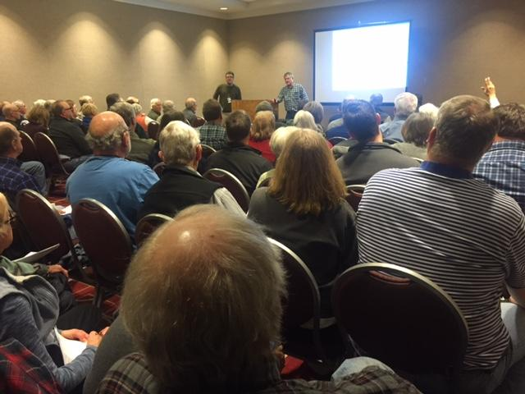
We are going to need a bigger room.
Excitement and energy in MLR is building year to year. Legislators and the press are beginning to recognize the work, generosity and impact lake home and cabin owners are having on our lakes. Word is finally getting out that lake associations, taken collectively, are the largest, most generous and hardest working conservation group in Minnesota, and they make significant contributions to the health of our most precious resource, our lakes and rivers.
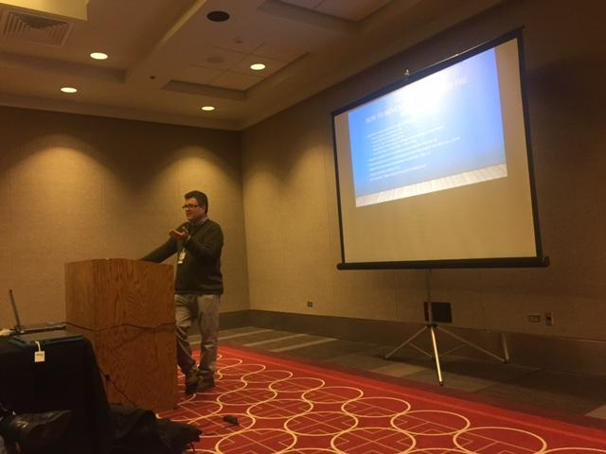
This year MLR Executive Director Jeff Forester gave a great recap of the year and presented a new grassroots advocacy model that will help protect Minnesota’s lake and river heritage for future generations. Minnesota’s iconic lakes and rivers have no better advocates than lake home and cabin owners. It is up to all of us, working together, to solve our water quality issues.
In 1993 when MLR was first formed by a small group of cabin owners from Lake Vermilion the annual meeting was just a few dozen people. Some of those original members attended this year. That is a remarkable complement and shows the true grassroots strength of the organization. The members of MLR deserve a clap on the back - together we have built the best grassroots lake and river advocacy force in the land of ten thousand lakes.
Some of MLR’s key activities and accomplishments in the last year:
- Continued Growth of Lake Association membership – MLR now largest lake association group in Minnesota.
- Strong media presence for lake issues in statewide and local press.
- Change in narrative at MN Legislature.
- Aquatic Invaders Summit.
- Webinar Series.
- Formation/Reformation of two COLA organizations in 2016.

But lake and river trends are not rosey. We all know personally how lakes have changed over the years. There is more to do, and MLR has a strategy for protecting our lake and river heritage into the future.
The MLR mission statement is, “Minnesota Lakes and Rivers Advocates protects Minnesota’s lake and river heritage by forging powerful links among lakes, lake advocates and policy makers.”
The first part of the mission captures a value all lake home and cabin owners share, heritage. We want to leave our lakes in rivers in at least as good, if not better, condition than we found them. We are doing much of this work for the benefit of our children and grandchildren.
The second part of the mission statement focuses on “links.” These links are critically important and will be the main focus of MLR work, in addition to pushing a pro-lake agenda at the Capitol. The two are closely connected.
Even if MLR is successful at pushing a pro-lake agenda at the state level, much of this work can be undone at the local level OR even if MLR fails at the state level, work can be accomplished at the local level.

One example is riparian buffers and shoreland development rules. For instance, the state does have minimum shoreland development standards but these are often undone with variance boards. Or in the case of riparian buffers, some counties were able to pass stronger riparian buffers above and beyond what is required by Minnesota law. Many good programs for lakes and lake protection efforts could move from the local level up to the state level. When lake associations increase their relationships and engagement in local policy making, they can have a huge impact that benefits lakes outside their area.
As MLR unifies our message and strategy across the state and brings more lake associations into partnership with all the lake associations in Minnesota, the impact of all will increase as will the energy and hopefully membership of individual groups.
Legislative efforts in St. Paul are a numbers game, but legislators do often act without that. By building relationships with legislators and bringing them into your lake association work, they will understand the issues you face, the value that your organization and other lake associations provide Minnesota, and they will be better able to represent their constituents issues in St. Paul.
Here is what your lake association can do to increase the impact we will all have on protecting lakes and rivers in Minnesota:
- Put your State Representatives, Senators and County Commissioners on your mailing list so that they receive your Newsletters and other materials, and know the work you are doing.
- Invite your State representatives, Senator and County Commissioners to a one-on-one coffee to learn what their vision is for the lakes and rivers in your area.
- Invite these elected officials to your annual meeting. Ask them in advance if they would like to simply attend, or if they would like to have a few minutes to speak and answer questions.
The goal is to build a relationship and educate them on the issues you are facing, the work you are doing to protect and enhance the public good of the lake. You want to learn why they believe what they do about water issues in your area, and what solutions they have. Let them know that your group is ready to be a part of the solution.
There is a role and a jurisdiction for lake home and cabin owners in protecting lakes and rivers in Minnesota. Lakes are a primary driver of both economics and quality of life in Greater Minnesota, and without lake associations across the state engaging on lake related issues, we will fall short of our goals to protect these values for future generations. Now is the time.
Jeff Forester is executive director of the Minnesota Lakes and Rivers Advocates.

MN Lakes & Rivers Advocates ~ PO Box 22262 ~ St. Paul, MN 55122
www.mnlakesandrivers.org ~ 952-854-1317 ~ judy@mnlakesandrivers.org

