Protecting Minnesota's waters: If you don't get involved, the job won't get done
What's needed is a new paradigm in managing our resources.
By Jeff Forester

DECEMBER 16, 2016 — 6:17PM - Star Tribune Commentary
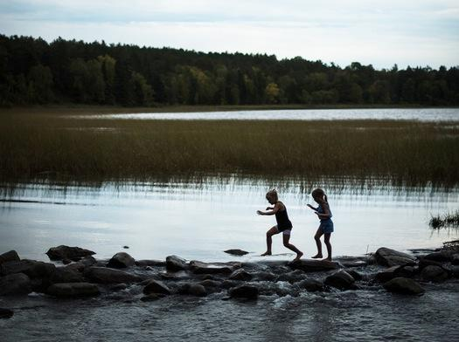
AARON LAVINSKY &#X2022; STAR TRIBUNEThe Mississippi Headwaters in Itasca State Park.

Much has been written about the divided electorate, the us vs. them story. But in Minnesota, there is one area where the electorate is unified.
On the Saturday after the election I spoke at a lake association in southwestern Minnesota, in a Lutheran church beside a lake. The coffee was weak, the lemon bars delicious.
President-elect Trump had won the surrounding county by 30 percentage points. As the meeting advanced, some issues began to emerge: Agricultural runoff and drain tiling practices were harming both water quality and fishing. Aquatic invasive species like zebra mussels and starry stonewort were a huge worry. Grants to help fund treatments to manage Eurasian watermilfoil and curly leaf pond weed had been cut; association members had paid for partial treatments themselves.
Those members complained that while they were constantly reminded they did not own the water, they did seem to own the problems. They were angry that they lacked the authority to make changes.
Later that same week I met with environmental groups in the Twin Cities, an area that Hillary Clinton won by 35 percentage points. At a fine restaurant in downtown Minneapolis, the coffee was bitter and the wild mushroom flatbread delicious. As the meeting advanced some issues began to emerge: Agricultural runoff and drain tiling practices were harming water quality, aquatic invasive species like zebra mussels and starry stonewort were a huge worry. Funding had been cut. Citizens lacked authority to make changes.
At the rural lake association meeting one of the members, in a U.S.-flag cap, had railed at me, saying we needed to “get the government to do their job,” to provide the services required to keep the lake clean and healthy. He wanted more funding, more regulation and more enforcement.
The environmentalist in the cities cried that to protect water we needed more funding, tighter regulations, better enforcement.
In short, the rural lake association members and the urban environmental leaders had the same view. Budgets and spending are perennial legislative hot topics, and the overall trend now leans toward less spending, lower taxes, fewer regulations and looser enforcement.
We have the data, and everyone knows from personal experience that water quality and fishing have begun to decline. No white paper, outreach, education, marketing plan or protest is going to change anything. In the late 1970s, ’80s and even ’90s we saw the most egregious pollution end. Our rivers no longer catch fire. But the top-down efforts by large agencies seems to have stalled, and now the trends are reversing. Industrial pollution is still an issue, but the real threat is different now: non-point source pollution, the results of millions of small decisions made by millions of people that over time destroy our water.
With the rise of large agencies to protect the public interest came a new paradigm — government should be run like a business. Citizens are consumers and we buy services from government, or even private providers, with taxes. Many government services became privatized, including our prisons, much of our military, and our schools.
The downside of this is that if citizens view themselves only as consumers, then they give up their jurisdiction to govern, to work with each other to advance the common good.
We need a new paradigm in resource management, and this is where Minnesotans may be able to have an effect. Minnesota’s story is a “Chronology of Water,” of Voyageurs, Ojibwe and Dakota paddling quiet lakes, of loggers driving booms down rapids to the mill, of grandfathers rowing canvass covered dinghies trolling for walleye, of learning to waterski, canoe and kayak, of the call of the loon.
Every Minnesotan has a memory of time on the water with family and friends. A cup of coffee early morning on the dock, or star gazing with the Milky Way reflected in the water below, or watching the roaring waters of Minnehaha Falls in spring, crossing the Stone Arch bridge at night or fireworks from Harriet Island in St. Paul.
In Minnesota water is bipartisan, central to the state’s identity and economy. Minnesota has more than 183,326 miles of shoreline, more than Florida, California and Hawaii combined. Our $12 billion annual tourism economy depends mostly on pristine lakes and rivers. There are more than 500 lake associations in Minnesota. The average length of ownership for a family cabin is 34 years.
Much has been written about the divisions among the electorate. But when it comes to water, rural and urban Minnesotans are singing from the same hymnal — they not only want to arrest the degradation of waters in our state, but to reverse the trend and leave our waters “better than we found them.”
There is only so much government can do. We Minnesotans will have to do it ourselves. So contact a lake association near a body of water you love. Become part of the process. Work to elect local government officials, local boards of appeal, zoning boards and county commissioners who not only value water, but understand that success will come by including the public in the decision making process.
It will have an impact. It may be the only thing that will.
Jeff Forester is executive director of the Minnesota Lakes and Rivers Advocates.
MN Lakes & Rivers Advocates ~ PO Box 22262 ~ St. Paul, MN 55122
www.mnlakesandrivers.org ~ 952-854-1317 ~ judy@mnlakesandrivers.org

